MONDAY | TUESDAY |  | WEDNESDAY |  | THURSDAY | FRIDAY | ENROLMENT
Hastings Happy Crafters  Time: 10.00-11.30am  All year activity  $4.00 per session.      This active craft group will inspire you to create by sharing skills and undertaking craft projects. All abilities welcome. We have craft supplies here to share or bring your own project. | Hastings Hot Trotters  Time: 9.00am  All year activity  FREE.  Meet @ Pelican Park Skate Park & enjoy  laughs conversation and exercise taking in various locations around Western Port.  Contact Denise on 0439 837 691 or curfam@bigpond.net.au.    for further info. |  | 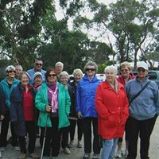 |  | Community Cooking  Time: 10.30- 1.00am    On Thursday’s we cook and prepare meals to supplement our Wednesday free food program. Meals made from reclaimed and donated food items. Volunteers needed. Contact us for further details. | ***New Foreshore Friends Community Playgroup***  Time: 9.00–11.15am  Gold Coin Donation  All parents & caregivers with children under 4 yrs. welcome.   | How to Enrol:      CONTACT: PH: 5971 9198  Email:hastingsch@bigpond.com  Or: FB Messenger  In person during office hours:    9.30-3.30pm Monday-Friday.  185 High St Hastings.  Left hand car park entrance  We aim to provide low cost classes everyone can participate in. If finances are a concern for you, please talk to our manager, in confidence, to make other arrangements.
Monday Muso’s  Time: 1.00-5.00pm  Come along and have a jam with other musically minded folk. $4.00 per person.  Check out the muso’s @ the FB page!  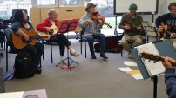  MondayMuso@HastingsCommunityHouse | Yoga & Meditation  Time: 10.30-11.45am  Cost: $8.00 per session.  Join our qualified instructor in an all-abilities yoga class followed by a relaxing meditation weekly on Tuesday’s.   |  | Free Food Wednesday  Time: 12.30- 2.00pm  Thanks to Oz Harvest, we now have a selection of fresh fruit, veggies, meat & other goodies available on Wednesdays.  No appointment or health care card needed. Please bring along a reusable cloth/plastic supermarket bag.    All welcome inclusive community support. |  | Italian for all  Time: 9.00am -8.00pm    Learn Italian like a local with our acclaimed tutor Rosella. Select classes throughout the day Rosella provides individual and group classes as well as online sessions. Immerse yourself in the language, culture & food od Italy! Call 0416 341 143 to discuss your needs. | Hastings Toy Library Sessions  Time: 10.30-12.00pm  Our very popular toy library interactive sessions will continue in 2025.  Dates to be advised end of Jan.  Open to all in the community, these sessions complement our playgroup and will run monthly. Structured fun for littlies 0-4years. FREE.  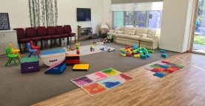 | Forms, Resumes, Cover Letters, Online Applications, Legal Matters and Tech Issues.  If paperwork / technology is getting you down, or you need assistance with updating your resume, writing a dynamic cover letter or completing an online application, we can help....Contact us to book a time.    COST DONATION
Breast Feeding Clinic run by Peninsula Health meets Friday’s @ the House  Time: 1.00-5.00pm  Contact the team on:    (03) 9784 2600. | The following services are available@ Hastings Community House:  Asuria- Assured People Services. Asuria works with employee’s ad governments to find long-term employment. 1800 773 338    @ Wed Thru Fri |  | Western Port Neighbourhood Watch  meet @ Community House monthly    contact FB www.facebook.com/WesternPortNHW |  | Hastings Hot Trotters  Time: 9.00am  All year activity  FREE.  Meet @ Pelican Park Skate Park & enjoy  laughs conversation and exercise taking in various locations around Western Port.  Contact Denise on 0439 837 691 or curfam@bigpond.net.au. | Hastings Community House Breakfast Club  Operates 5 days a week from 8.30-9.30am from Hastings Primary School kitchen. Serving toast, pancakes & fruit to the Hastings PS kids during the school terms. If you would like to donate to this program please contact the House.   | 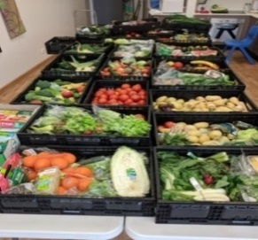  We value and thank our food relief sponsors: Oz Harvest Melb & Woolworths Hastings & Community Donations that assists us with reducing food insecurity and accessibility weekly in our community.
.

Check out our website @  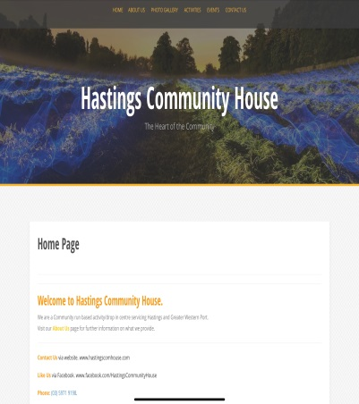  www.hastingscomhouse.com  The following services are available @ Hastings Community House:  Asuria- Assured People Services. Asuria works with employee’s ad governments to find long-term employment. 1800 773 338  @ Wed Thru Fri  We support the Hastings Respectful Relationship Group in promoting healthy respectful relationships across Western Port.  Ask us how you can get involved.  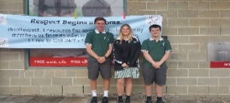 | 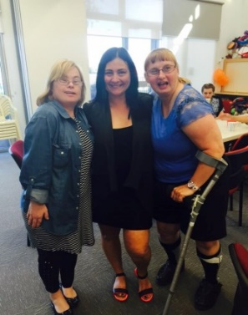  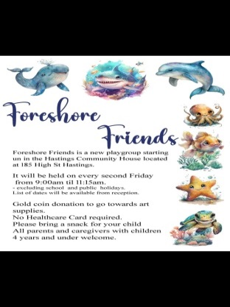 | 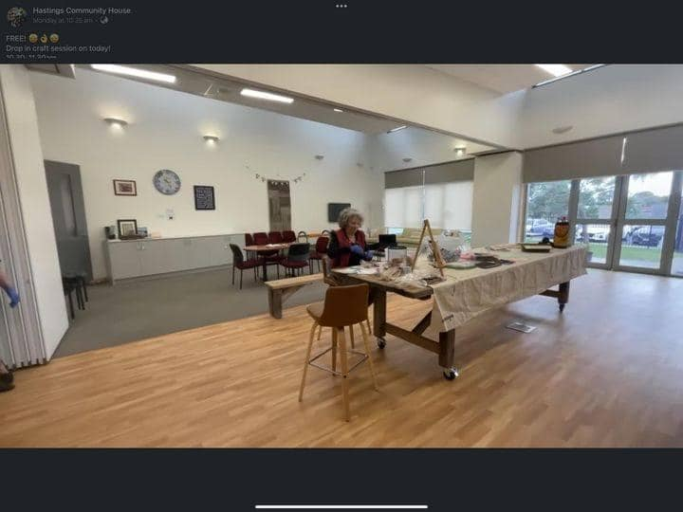  Our volunteers are essential to the successful running of our weekly programs. Each week many people asssit us in providing over 79 hrs of volunteering to assist our programs.For more information about volunteering contact us or check out:  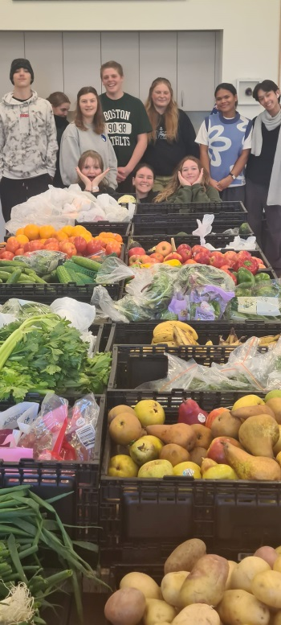  https://www.mornpen.vic.gov.au/Community-Services/Volunteering | Hastings Community House  TERM 1  29 Jan – 04 April 2025  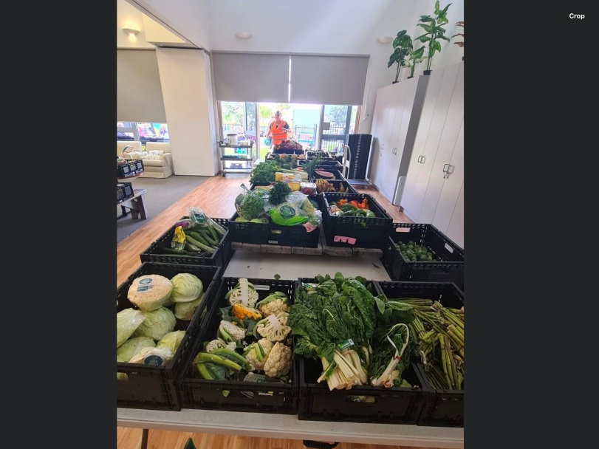  Peninsula Health Complex  185 High St Hastings 3915  Melways Ref: 154 F11  PH: 5971 9198  Email: Hastingsch@bigpond.com  Website: www.hastingscomhouse.com    www.facebook.com/HastingsCommunityHouse  Serving soup61 & smiles across Westernport








 |  | Seniors Playgroup. A time out session for adults to chill and relax with some favourite group activities. Cryptic crosswords, mah-jong, chess or maybe just a quick book club discussion, Senior playgroup is all about relaxing your way.
 |  | EXPRESSIONS OF INTEREST SOUGHT
Soapbox Supper Presenters.
Mum’s n Bubs Playgroup.
Op Shop Tour Trip Ideas.

